

“Python Experiment no.1”

Name – Pratyaksh Singh
Sapid - 590023001
Batch - B45
Faculty Name – Dr. Amit Ranjan

Q1. Install Python and write the steps of installation and understand difference between scripting and interactive modes in IDLE.
Steps to Install Python :
Step 1: Download Python
- Go to the official website: https://www.python.org
- Click on Downloads
- Download the latest Python version suitable for your OS (Windows).
Step 2: Run the Installer
- Double-click the downloaded .exe file.
- **IMPORTANT: Check the box “Add Python to PATH”
- Click Install Now
Step 3: Complete Installation
- Wait for the installation to finish.
- Click Close.
Step 4: Verify Installation
- Open Command Prompt
- Type: python –version
Step 5: Open Python IDLE
- Go to Start Menu → Python → IDLE (Python Shell)

Difference Between Interactive and Scripting Mode :-
Feature | Interactive Mode | Scripting Mode
Execution | Line by line | Entire program
Prompt | >>> | No prompt
File saving | Not saved | Saved as .py
Usage | Testing, practice | Real programs
Speed | Fast for small tasks | Best for full programs

Q2. Create a variable to store your age and print its type using type().
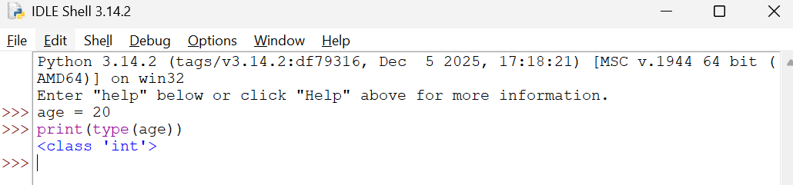

Q3. Declare a string variable called x and assign it the value “Hello”. (a)Print out the value of x.
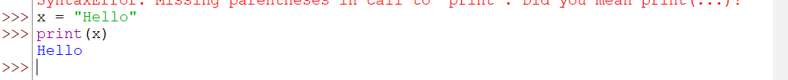

Q4. Take different data types and print values using print function.
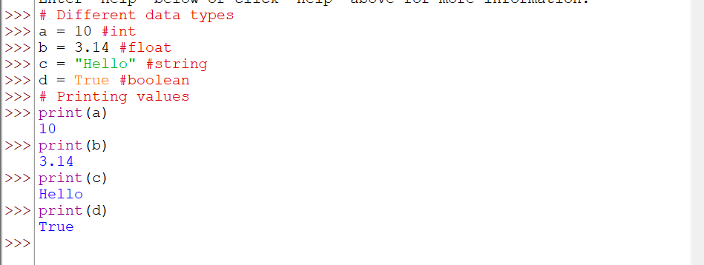

Q5. Declare these variables (x and y) as integers. Assign a value of 9 to x, Assign a value of 7 to y, perform addition, multiplication, division and subtraction on these two variables and Print out the result.
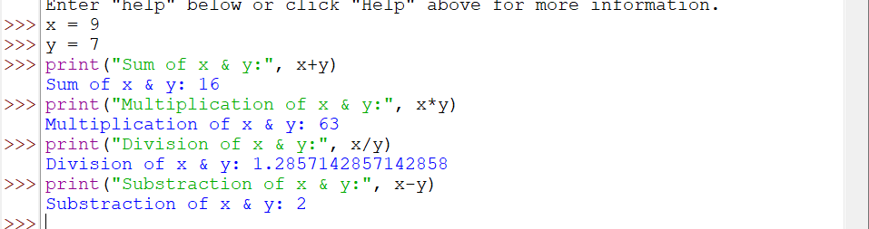

Q6. Write a program to compute the length of the hypotenuse (c) of a right triangle using Pythagoras theorem.
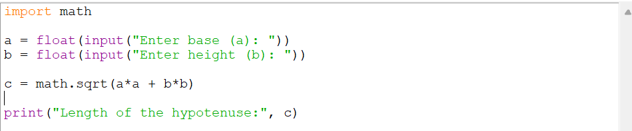
Output -

Q7. Write a program to find simple interest.
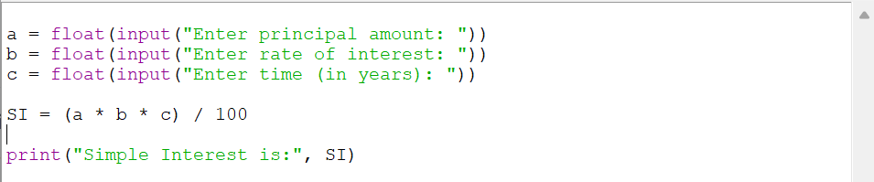
Output –
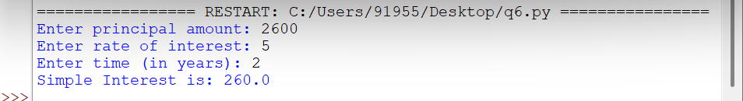

Q8. Write a program to find area of triangle when length of sides are given.
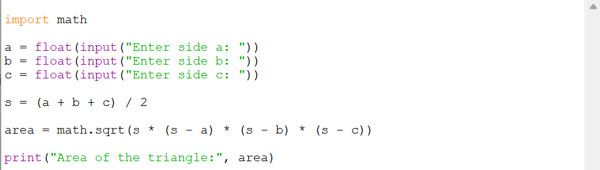
Output –
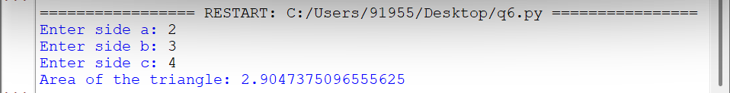

Q9. Write a program to convert given seconds into hours, minutes and remaining seconds.
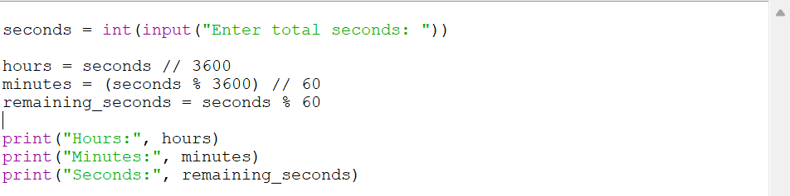

Output –
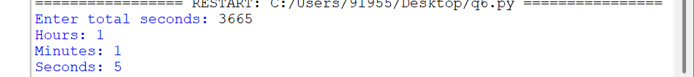

Q10. Write a program to swap two numbers without taking additional variable.
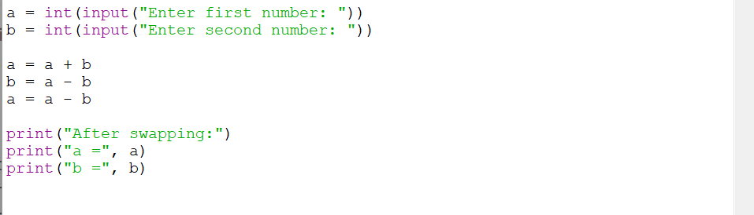
Output –
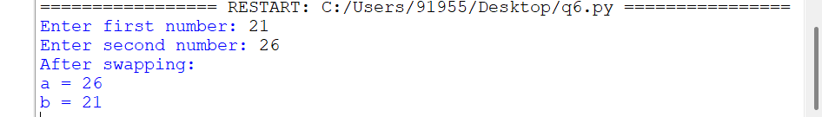

Q11. Write a program to find sum of first n natural numbers.
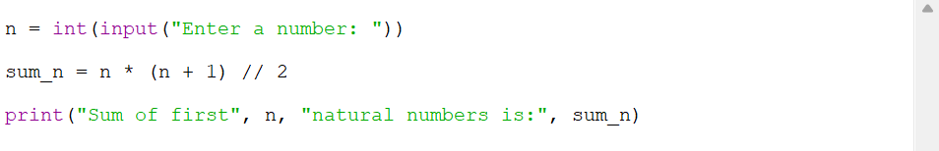
Output –

Q12. Write a program to print truth table for bitwise operators (&, | and ^ operators).
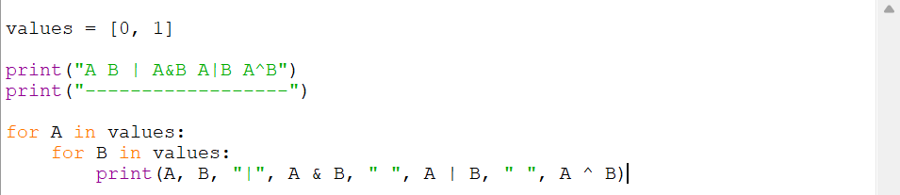
Output –
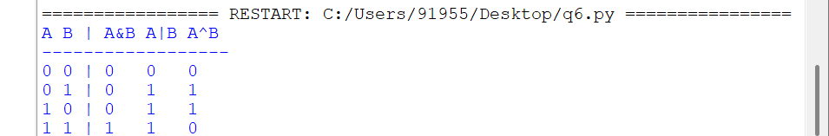

Q13. Write a program to find left shift and right shift values of a given number.
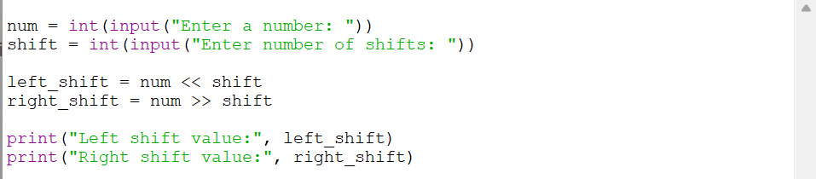
Output –
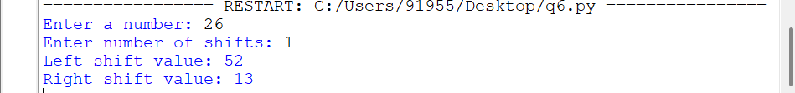

Q14. Using membership operator find whether a given number is in sequence (10,20,56,78,89).
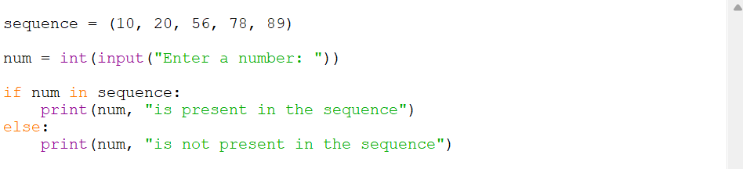
Output –

